- ll Frequency of activity equals 4.4 days
Jefferson County Law Center
Fitness Equipment Impact on Employees Health
Jefferson County Public Health Quality Improvement Storyboard

STUDY
Use Data to Study Results of the Test
PLAN
Identify an Opportunity and Plan for Improvement

1. Getting Started
To address health issues in Jefferson County, the Jefferson County Wellness Coalition was established. An area for improvement identified county-wide was worksite wellness. Coalition members chose to focus their efforts on the Jefferson County Law Center to test the implementation of QI in worksite wellness. The Law Center houses the Fairfield Police Department, Jefferson County Sherriff’s office and the Jefferson County Jail. The goal of the QI project was to make a positive impact on the activity level of 50 Jefferson County Law Center employees resulting in health improvements.

Based on a Behavior Risk Factor Surveillance System (BRFSS) survey that was given to the employees before the installation of fitness equipment, the following was determined.

The average age of the 44 law center employees that filled out the survey was approximately 38 yrs of age. The average time working at the law center was 8 yrs and approximately 60% of the employees were male. When asked if they had used the old fitness center only 36% indicated doing so. When asked if they had been trying to reduce their stress level 58% indicated doing so. As a group the average Body Mass Index (BMI) was approximately 28, which is higher than the recommended healthy BMI range of 25 or lower.

The main area of interest for this QI project was to increase the physical activity level of the law center employees. At the beginning of this project the law center employees reported doing:
- An average of 4.4 days of moderate activity per week.
- An average of 86 minutes of moderate activity on work out days.
- An average of 3.4 days of vigorous activity per week.
- An average of 101 minutes of vigorous activity on work out days.

2. Assemble the Team
The QI team consisted of staff from the Maharishi University of Management (Ken Daley and Raul Calderon, Jr., Ph.D) and the Jefferson County Health Center (Ginny Hughes).

3. Examine the Current Approach
Based on the BRFSS and a discussion with the Fairfield Police Chief, the Police Department and the Sherriff’s Office were in need of exercise to improve their overall health and reduce stress. The current exercise equipment at the facility was not being used and there were multiple barriers to exercise uncovered during the interview with Police Chief Harvey. See Fishbone Diagram.

4. Identify Potential Solutions
AIM statement - By February 28, 2011, the Jefferson County Law Center staff will increase their frequency and duration of physical activity.

To achieve the intended results, the QI team decided to: 1) install new exercise equipment at the Law Center to promote physical activity, reduce stress and improve overall health of Law Center employees, 2) conduct a training session on proper equipment use, and 3) train an officer to train other staff members.

5. Develop an Improvement Theory
If the barrier of having access to fitness equipment and education on how to use the equipment is removed, then the Law Center employees will increase their frequency and duration of physical activity.

7. Check the Results
A second BRFSS was given approximately 12 weeks after installing the new exercise equipment to determine if Law Center employees were able to increase their frequency and duration of physical activity and decrease BMI. The following results were found:
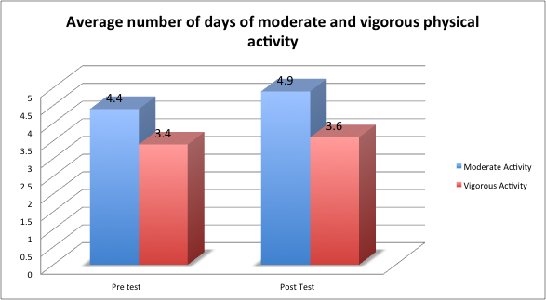

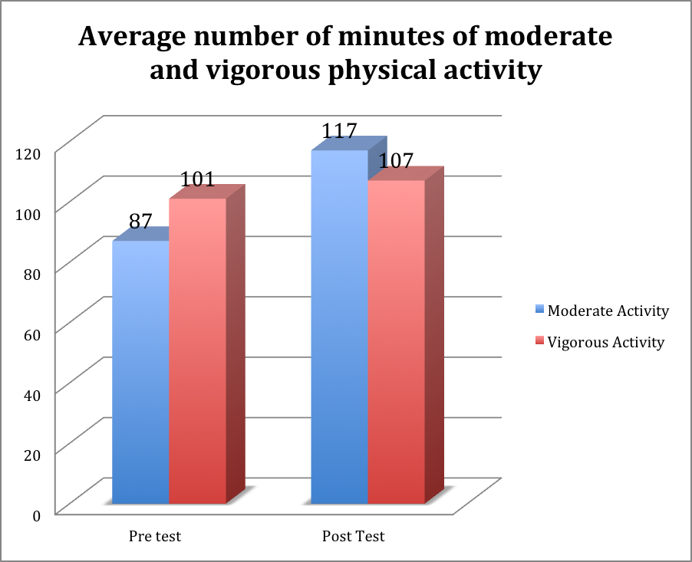

A small reduction was also found in the average group BMI score (pretest 28 vs. posttest 27.7). Lastly, the percent of employees trying to reduce their stress level rose from 58% to 78% at posttest. These results are in the predicted direction and appear to support the aim of this QI project.

ACT
Standardize the Improvement and Establish Future Plans
DO
Test the Theory for Improvement
6. Test the Theory
Fitness equipment was installed in December 2010. The equipment included three spinner bikes, a back extension machine, chin/dip/leg raise machine, treadmill, rowing machine, elliptical trainer, free weights and benches, exercise mat, speed ropes, rubber exercise tubing, rubber flooring and educational wall charts.

One spinner bike was placed in the dispatch area for easy access by those employees who cannot leave the area during their 12-hour shift.

The new gym is accessible 24 hours a day and off-shift exercising is encouraged by allowing families to use the equipment.

The team interviewed the Chief of Police and County Sheriff three weeks after installation and both said the equipment was being used by more staff members regularly and was greatly appreciated by the staff.

One Train-the-Trainer session for officers to learn to mentor their peers took place on January 26, 2011. Eight officers were present at the training. The Police Chief felt this single session was sufficient to cover their need. During the 1.5-hour session basic exercise prescription was covered as well as a hands-on use of the equipment.
8. Standardize the Improvement or Develop New Theory
The availability of exercise equipment and the support of management allowing employees to exercise during work time appear to have made an impact on employee’s frequency and duration of exercise. The maintenance of these activities will help ensure a positive effect on health outcomes which could impact overall health.

9. Establish Future Plans
The QI Team plans to have Law Center staff complete another BRFSS after the equipment has been installed for one year. Results will be used to determine if the improvement activities implemented at the Law Center are best practice for work site wellness initiatives.

